DOD Interagency Collaborative for Program Improvement (ICPI) On-boarding

Contents

Introduction 1

DOD at ICPI 2

Current Staff Participation: 2

Working with ICPI 2

Step 1: Submitting an ICPI Engagement Form 2

Step 3: Visit ICPI 2

ICPI’s Location 2

Entrance to SA-22 2

Metro Access 3

Restrooms 3

Emergency Exits 3

Additional Information for on-site staff: 4

1. ICPI Onboarding/Offboarding Checklist: 4

2. Getting a key fob for lobby 4

# Introduction

The ICPI is comprised of data analysts and technical experts from six PEPFAR implementing agencies: the U.S. Agency for International Development (USAID), the Department of Defense (DoD), the Peace Corps, and the agencies from the Department of Health and Human Services, which include the Centers for Disease Control and Prevention (CDC), the Health Resources and Services Administration (HRSA), and the Substance Abuse and Mental Health Service Administration (SAMHSA), and the Census Bureau.

ICPI staff collaborate on projects that advance data access, analysis, and use from multiple data streams, including program results and epidemiologic, financial, and expenditure data.

ICPI’s Strategic Plan can be found on pepfarii.net here: <https://www.pepfar.net/OGAC-HQ/icpi/Shared%20Documents/Management/Strategic%20Documents/ICPI%20FY18%20Strategic%20Plan_01092018_DV02.docx>

## Orientation/Training

After reviewing the Stategic Document you will understand ICPI’s purpose, structure, and scope of work. Additional orientation/training materials are available to help you orient yourself to PEPFAR and its data.

## DOD at ICPI

### Current Staff Participation:

|  |  |  |  |  |  |
| --- | --- | --- | --- | --- | --- |
| Role | Name | Email | Location | LOE | Clusters |
| Lead | Anne Thomas | Anne.g.thomas.ctr@mail.mil | San Diego | 25% |  |
| On-site Lead | Brittney Shook | [Brittney.n.shook.ctr@mail.mil](mailto:Brittney.n.shook.ctr@mail.mil) | ICPI | 100% | Financial, OCM |
| Analyst | Shaylee Metha | [Shaylee.p.mehta.ctr@mail.mil](mailto:Shaylee.p.mehta.ctr@mail.mil) | ICPI | 100% | DAQ, Diagnosis, SIMs, Tx, OCM |
| Analyst | Barbara Ddmulira | bddamulira@hivresearch.org | Rockville | 25% | Prevention |
| Analyst | Couper Turkewitz | cturkewitz@hivresearch.org | Rockville | 25% | DAQ, Diagnosis |
| Analyst | Stephanie Hess | [Stephanie.a.hess3.ctr@mail.mil](mailto:Stephanie.a.hess3.ctr@mail.mil) | San Diego | 25% | SIMs |
| Analyst | Jonathan Davitte | [Jonathan.m.davitte.ctr@mail.mil](mailto:Jonathan.m.davitte.ctr@mail.mil) | San Diego | 10% | DAQ |
| Analyst | Eniko Akom | [eakom@hivresearch.org](mailto:eakom@hivresearch.org) | Rockville | 10% | Prevention |

# Working with ICPI

To request to be added to the ICPI List serves please email the ICPI on-site lead or [ICPI@state.gov](mailto:ICPI@state.gov) with your request. The different listserv groups can be found via the link below:

<https://www.pepfar.net/OGAC-HQ/icpi/Shared%20Documents/Forms/AllItems.aspx?RootFolder=%2FOGAC-HQ%2Ficpi%2FShared%20Documents%2FCommunications%2FMaster%20ICPI%20Contact%20List&FolderCTID=0x012000C815322C717A7E4B8164EA374FA254EC002682B939F9BED347BD49E43D77D3C691&View=%7B94C838B2-E166-4122-B8B4-7BEB9E1BC12B%7D>

## Step 1: Submitting an ICPI Engagement Form

1. All visitors must submit an engagement form via pepfarii.net at least two weeks prior to their visit. The engagement form is electronic and is located on pepfarii.net at this link:

<https://www.pepfar.net/OGAC-HQ/icpi/Lists/Engagement/NewForm.aspx>

1. Email the on-site lead with travel dates.
   1. Be sure Emergency Contact Information is on file

# Step 2: Visit ICPI

## **cid:image001.jpg@01D0566B.29F07BE0**ICPI’s Location

**SA-22**

**10th Floor**

Street Address

1800 G Street, N.W., Room 10200

Washington, D.C.  20006

Main Tel: (202) 663-2440

Main Fax: (202) 663-2979

### Entrance to SA-22

The entrance to SA-22 – also known commercially as the Northwestern Building – is located on the south side of G Street, between 18th and 19th Streets. Similar to SA-29, there are two revolving door entrances leading to a lobby area

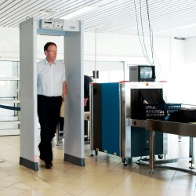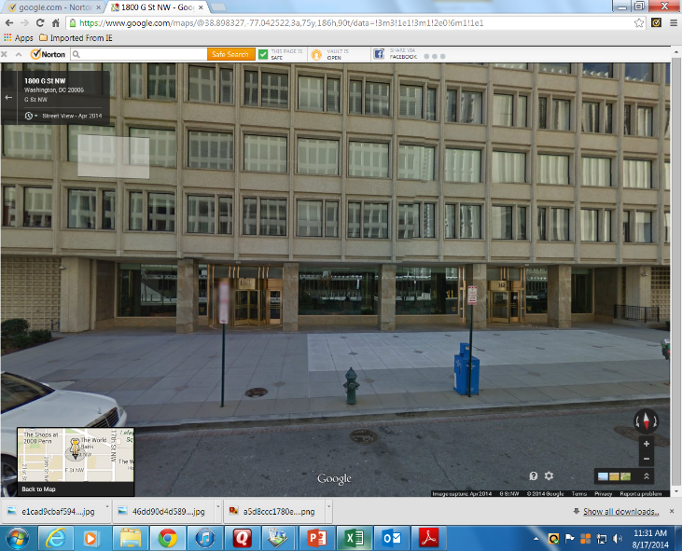Access to the elevators is gained through entry on the east side of the lobby (to the left of the reception desk).

EVERYONE – staff, visitors, etc. – must clear the magnetometer (metal detector); additionally, all bags, packages, purses, briefcases, etc. must pass through the x-ray machine. Staff MUST show the uniformed guards their State Department ID badge/DOD CAC Card/US Driver’s License. You must clear the magnetomer/x-ray machine each and every time you enter the building

### Metro Access

The closest Metro Rail stations are:

Farragut West (Orange, Blue & Silver lines)

Farragut North (Red line)

Nearby Metro Bus route stops include:

11Y, 3Y, 80, S1, 16Y, 32, 36, 37, 39, H1, L1,

38B, N2, N4, N6, P17, P19, W13, D1, D3,

D5, D6, L2, DC Circulator, 42, 43, G8,

N3, X1, S2, S4, X2, 31

Visit [www.wmata.c](http://www.wmata.com/)om

### Restrooms

Two sets of restrooms are located adjacent to and on either side of the elevator lobby (highlighted in green to the right).Entry is outside of the office suite proper.

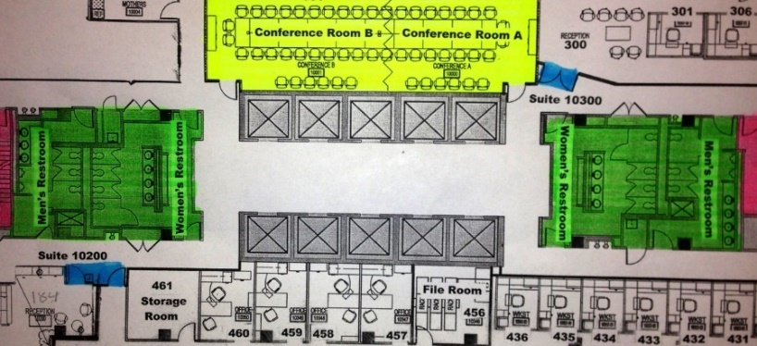

### Emergency Exits

In the event of an emergency, DO NOT use the elevators. There are two sets of exit stairwells located adjacent to and on either end of the elevator lobby (highlighted in pink to the right). They are next to each set restrooms.

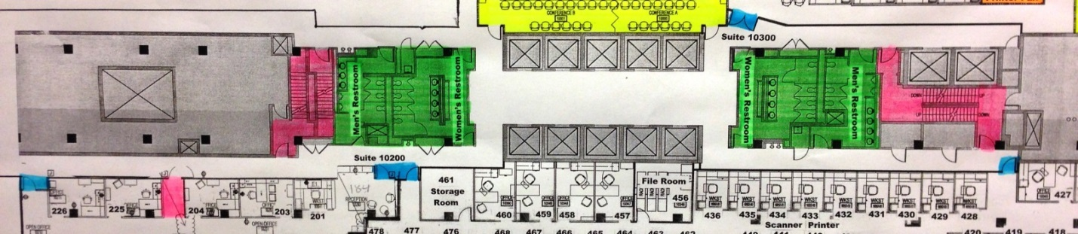

### Dress Code

DRAFT (BELOW)

# Additional Information for on-site staff:

Staff who sit at ICPI 3 or more days per week are eligible to receive a lobby key fob and a state department ID badge. This process will vary depending whether or not the staff member is WRAIR or ICPI.

## ICPI Onboarding/Offboarding Checklist:

Insert link

## Getting a key fob for lobby

Xxx

## Security Access

Xxx